Covid Reporter

There are several websites that report on Covid Panademic and some provide data that you can process yourself. The following website provides some interesting utilities:

<https://ourworldindata.org/covid-vaccinations?country=~USA>

For example, here is a graph showing the cumulative number of doses administered:

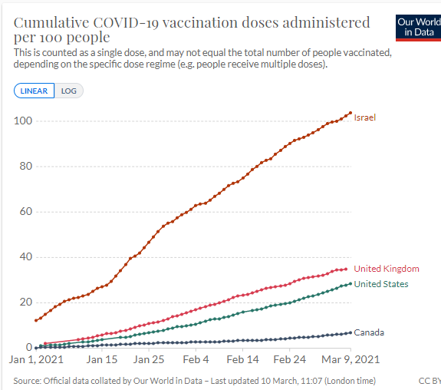

You are going to write a program that will produce a variety of reports based on the raw data.

In order to make the data more manageable a class called CovidData is provided. You will write an application program that will use the CovidData class to store all the daily covid data for all the countries in the world, this means there are about 74,000 lines of data!

Here are the details of the CovidData class:

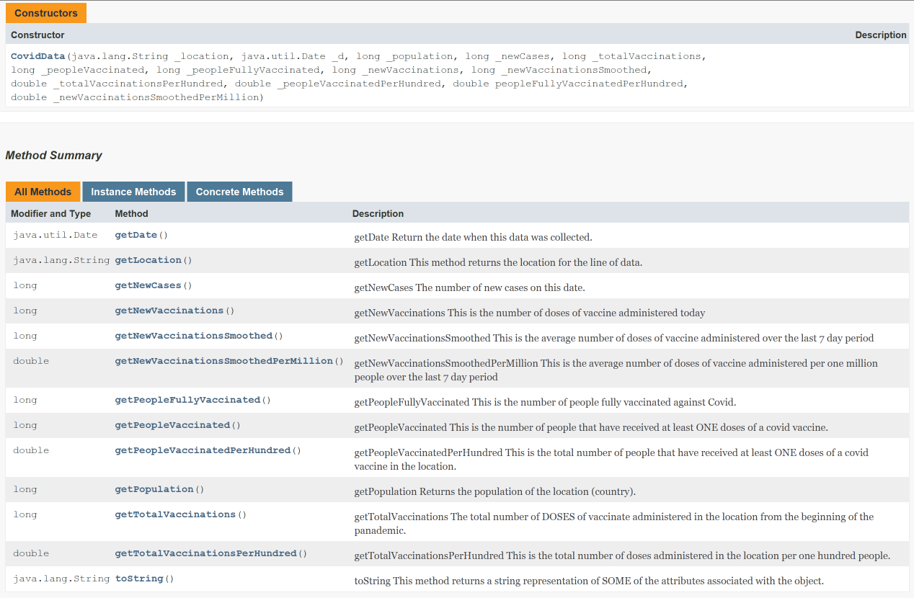

**Sample Program**

To help you out your instructor has provided the following sample program (SampleCovidProgram.java) that can read a single line out of the covid datafile, create a single instance of the CovidData class and calculate some statistical data. You can use this as a starting point.

Here is a sample run (user input is shown in bold underline):

Enter the name of the data file: **c:/temp/twoLineSampleDatafile.csv**

Data for Canada on 03/08/2021

New Cases: 4,048

New Case/1M: 107.3

New Vacc: 86,679

New Vacc/100: 0.230

**Covid Report Application**

Write an application that will:

* Read the full Covid datafile and create an arraylist of CovidData objects
* Support the following menu options

1. Allow the user to establish a filename where all reports will be output
2. Report of Daily New Cases
3. Daily New Vaccination Report

**The Covid Datafile**

The datafile is a .csv file containing the following information. Here is what the data looks like in Excel. An excel spreadsheet is provided so that you can review the data though you should read the .csv file in the application.

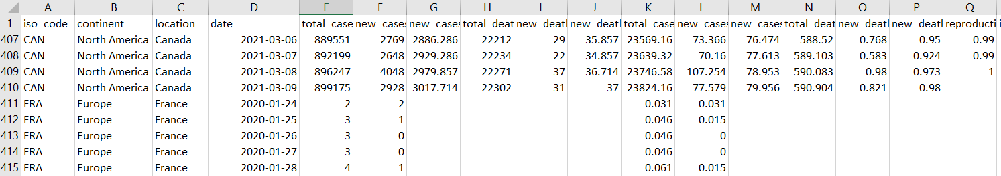

All the data is “,” delimited so you can use:

data = inFile.nextLine();

String [] answer = data.split(",");

to read a line and then split it into an array of Strings.

You’ll need to check if any of the numeric fields are null before converting then to an int or double. Based on this split method here are what some of the columns represent:

* answer[0] is the ISO country code
* answer[1] is the continent
* answer[2] is the location (country)
* answer[3] is the date
* answer[4] is the total number of cases

The sample program provided identifies all the columns you will require.

**Report of Daily New Cases**

Given a country name you should produce a report similar to the one shown below. Output should be written to a specified output filename that is established using option 1.

New Case Report for Canada

Date New Cases New Cases/1M

01/26/2020 1 0.0265

01/28/2020 1 0.0265

01/31/2020 2 0.0530

02/05/2020 1 0.0265

02/07/2020 2 0.0530

02/17/2020 1 0.0265

. . .  
03/07/2021 2,648 70.1603  
03/08/2021 4,048 107.2541  
03/09/2021 2,928 77.5790

**Daily New Vaccination Report**

Given a country name you should produce a report similar to the one shown below. Output should be written to a specified output filename that is established using option 1.

New Vaccinations/Day Report for Canada

Date New Vacc New Vacc/100 Ttl Vacc Ttl Vacc/100

12/15/2020 718 0.0019 723 0.0019

12/16/2020 2,300 0.0061 3,023 0.0080

. . .

03/07/2021 57,567 0.1525 2,387,189 6.3250

03/08/2021 86,679 0.2297 2,473,868 6.5547

03/09/2021 69,385 0.1838 2,543,253 6.7385